Table of Contents

Introduction 2

Why Azure Virtual Desktop (AVD)? 2

Azure Compute Sizing for AVD VMs 3

Creating a Master image for AVD deployment 3

Pre-requisites to create a Master Image for AVD host pool 3

Steps to create the virtual machine 4

How to connect to VM 8

Install NX software 10

Master/Golden image for host pool 15

Deploying a License Server for NX 22

Azure Virtual Desktop High-Level Architecture 28

AVD Deployment 30

Creation of Host pools 30

Creation of Application group 37

Creation of Application Workspace 41

Addition of roles to the Resource group 44

Addition of users to these above roles 45

Configuring Remote Desktop Application 45

NX Test Methodology 48

Running NX ATS certification tests 48

How to Install and Use ATS Certification Tests 49

ATS / Crash Tests 50

How to run the ATS Tests 50

ATS Test Result analysis 56

Running NXCP test suites 58

How to Install and Use NXCP Certification Tests 58

Running Manual tests 65

Summary 69

Additional Points 69

# Introduction

This deployment guide will take you through all the steps required to deploy Siemens NX on AVD multi-session Hosts and run the NX test suites on NVadsA10v5-series VMs of the Azure cloud. This guide will walk you through the deployment of AVD session hosts, Install NX, NVIDIA drivers, configuring the license server setup for NX and present the results obtained by running the NX test suites like ATS and NXCP on AVD Multi-session Hosts with multiple users.

# Why Azure Virtual Desktop (AVD)?

Azure Virtual Desktop (AVD) is a VDI solution provided by Microsoft. It allows organizations to host and manage virtual desktops and applications in the cloud. Azure Virtual Desktop is a free service and can be used with your existing Microsoft 365 or Windows per-user licence. There are no additional licence costs, it’s a familiar protocol, we’ve all used windows remote desktop service. Azure virtual desktop has built in security as well as conditional access control along with providing secure login via multifactor authentication. AVD allows you to quickly pop an environment and add resource as you need with a convenient pay as you go structure, with essentially no IT infrastructure overheads. Azure virtual desktop also provides integration with other platforms like Citrix or VMware to provide a richer desktop experience

**Below are the key aspects of Azure Virtual Desktop**

* **Virtual Machines (VMs):** Leverages Azure VMs to run virtualized instances of Windows desktops. These virtual machines can be customized based on the organization’s needs, supporting different configurations and resource allocations.
* **Desktop Virtualization:** Employs desktop virtualization technologies to separate the desktop environment from the physical device.
* **Remote Access:** Provides a remote access solution, enabling users to connect to their virtual desktops and applications over the internet. This is particularly useful for scenarios where employees need to work from different locations.
* **User Profiles and Data Management:** Supports user profiles and data management to ensure a consistent and personalized experience for users. Profiles and data can be stored centrally to allow for seamless access from different devices.
* **Scalability:** Organizations can scale their virtual desktop infrastructure up or down based on demand. AVD enables flexible scaling to accommodate varying workloads, ensuring optimal resource utilization.
* **Integration with Azure Services:** Integrates with other Azure services, such as Entra ID, Azure Security Center, and Azure Monitor. This integration enhances security, compliance, and management capabilities within the virtual desktop environment.
* **Multi-Session Windows 11:** Includes support for multi-session Windows 10 and 11, allowing multiple users to share a single virtual machine while maintaining individualized desktop sessions.
* **Application Virtualization:** In addition to desktops, AVD supports the virtualization of applications. This allows organizations to centrally manage and deliver applications to users without the need for local installation.

**Azure Virtual Desktop resources and links:**

1. **How to Videos:** <https://learn.microsoft.com/en-us/troubleshoot/azure/virtual-machines/windows/how-to-videos-windows-virtual-desktop>
2. **Prerequisites for AVD:** <https://learn.microsoft.com/en-us/azure/virtual-desktop/prerequisites?tabs=portal>

## Azure Compute Sizing for AVD VMs

For NX deployement and certification, we have used the following NVadsA10v5-series Virtual Machines. These virtual machines are powered by NVIDIA A10 GPUsCPUs with a base frequency of 3.2 GHz, all-cores peak frequency of 4.0 GHz. With NVadsA10v5-series Azure is introducing virtual machines with partial NVIDIA GPUs. The below two configurations are used for testing NX.

|  |  |  |
| --- | --- | --- |
| VM Size Name | vCPUs (Qty.) | Memory (GB) |
| Standard_NV12ads_A10_v5 | 12 | 110 |
| Standard_NV18ads_A10_v5 | 18 | 220 |

The NX certification is primarily conducted on a Standard_NV12ads_A10_v5 Azure VM, with an additional performance test case run on a Standard_NV18ads_A10_v5 VM for comparison.

The below link provides the session host Virtual Machine sizing guidelines for various types of workloads based on the requirements of users

<https://learn.microsoft.com/en-us/windows-server/remote/remote-desktop-services/virtual-machine-recs>

# Creating a Master image for AVD deployment

Creating a master image for Azure Virtual Desktop (AVD) deployment ensures faster deployment, consistent configurations, and optimized performance across session hosts. It simplifies application installation, environment setup, as changes can be made to the image and applied to new hosts, reducing manual effort every time and ensuring uniform security and compliance. By using a pre-configured image, organizations can streamline AVD management, reduce deployment inconsistencies, and maintain a secure and efficient virtual desktop environment

## Pre-requisites to create a Master Image for AVD host pool

1. An Azure Subscription
2. Virtual machine
3. Appropriate VM quota availability in the subscription (In our case, NVv5 SKU is used)
4. Admin privileges
5. NX 2312 software to install on the VM before creating a Base Image

### Steps to create the virtual machine

1. Login to the Azure portal, search for Virtual Machines in the portal

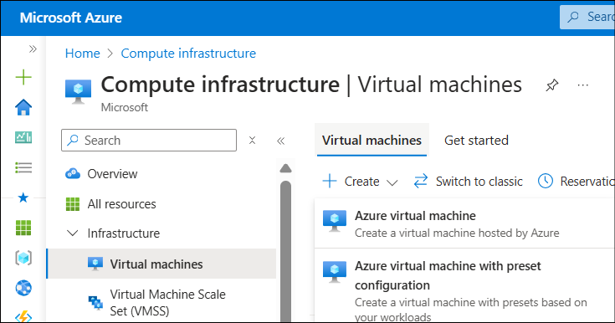



1. Create a Virtual Machine in the desired region, use the terms as shown in the image below

1. Selecting OS Image and VM size:

**Image selection:** Select the Windows 11 multi-session Image

**Note:** For multi-user scenarios in AVD hosts, multi-session Image should be selected

**VM Size Selection:** for our NX AVD certification, we are selecting NVv5 VM with A10 GPUs

1. Select Inbound Port Rules:

For login to the Windows VM, we must set RDP port 3389

1. Disk selection:

Under *Disks* tab, select the default OS disk size as 127 GB, and select the OD disk type as **Premium SSD**

1. Virtual Network Creation:

Select the default settings populated under the networking tab, select the delete public ip and NIC and then select management button

1. Now for the tabs Management, monitoring, advanced and tags keep all the default settings as it is and move to the Review + Create tab
2. Review and create

Now select the Review + Create button and see all the tests are passes or validated

1. Create Virtual Machine: Click the create button and wait for some time for the deployment of the VM, once deployed you can go to the resource.

### How to connect to VM

1. From the Above created VM, On the Overview page for your virtual machine, Select the Connect > RDP.

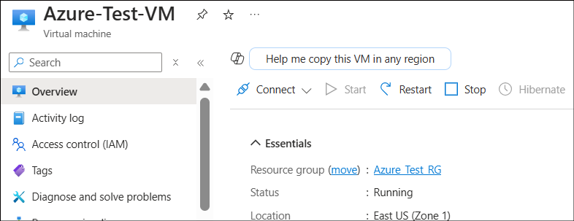

1. In the **Connect** with RDP tab, keep the default options to connect by IP address, over port 3389, and click Download RDP file.

1. Open the downloaded RDP file and click Connect when prompted.

1. In the Windows Security window, select More choices and then Use a different account. Type the **username** as localhost\username, enter the **password** you created for the virtual machine, and then click **OK**.
2. You may receive a certificate warning during the sign-in process. Click **Yes or Continue** to create the connection.

### Install NX software

1. Download the NX using below link

[support.sw.siemens.com/en-US/product/209349590/download/PL20231204727760623](https://support.sw.siemens.com/en-US/product/209349590/download/PL20231204727760623)

1. Navigate to SiemensNX-2312_wntx64\SiemensNX-2312_wntx64. Click on Launch.exe  
   A screenshot of a computer

   AI-generated content may be incorrect.

1. It opens the installer UI. Click on **Install NX**

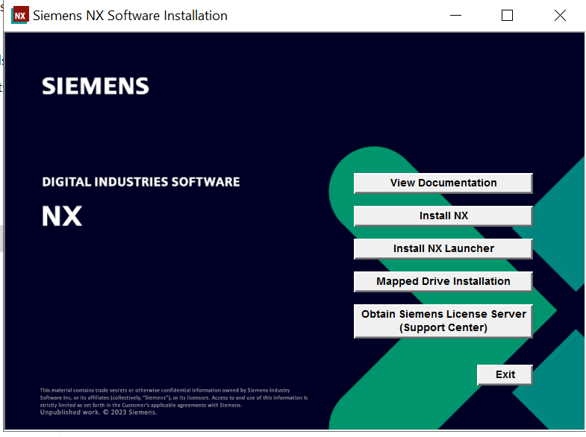

1. Select the Language and click ok

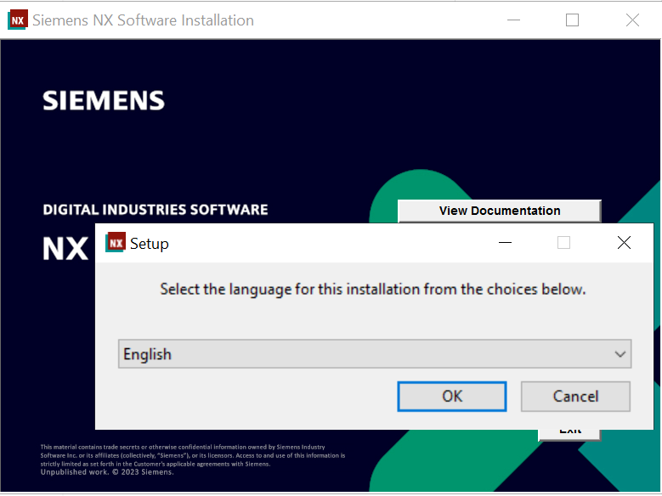

1. Installing the prerequisites
2. Click Next

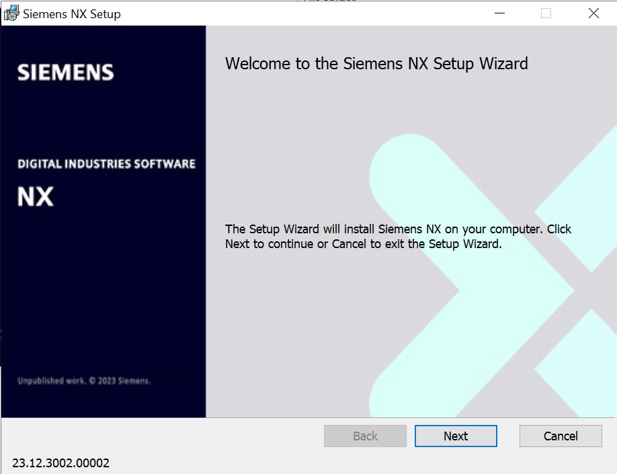

1. Select the location to install and click next

1. Enter the NX License server details and click Next

1. Select the Runtime Language and click Next

1. Review the selected things and click Install

1. Installation starts and shows the status

1. Click Finish to complete the setup

1. Modify the Environment Variable by updating the SPLM_Lic_server to reflect the license server machine's details. The format should be as follows:

SPLM_LICENCE_SERVER=29000@[License_Server_IP]

Replace [License_Server_IP] with the actual IP address of your license server.

For example, if your license server's IP address is 192.168.1.100, the entry would look like this:

SPLM_LICENCE_SERVER=29000@192.168.1.100

### Master/Golden image for host pool

A Golden Image is a pre-configured virtual machine (VM) template that can be applied to servers, disk drives, or desktops. It may also be referred to as a clone image or master image, and they are commonly used by system administrators to develop consistent system environments.

By creating this custom image, you ensure uniformity in your Azure Virtual Desktop environment, saving significant time and effort in setting up individual session hosts. Instead of configuring each desktop separately, you can simply deploy your golden image to quickly provision new session hosts that are already equipped with all necessary software and configurations.

#### **Steps to create an image from an Azure VM**

1. When creating a new VM for your golden image, make sure to choose an OS that's in the list of [supported virtual machine OS images](https://learn.microsoft.com/en-us/azure/virtual-desktop/prerequisites#operating-systems-and-licenses). We recommend using a Windows 10 or 11 multi-session (with or without Microsoft 365) or Windows Server image for pooled host pools.
2. If user want to take snapshot of base VM , they can first take snapshot and then go with Image creation steps
3. Sign in to the VM and start customizing it with apps, updates, and other things you'll need for your image.
4. Install the latest Windows updates.
5. Complete any necessary cleanup, such as cleaning up temporary files, defragmenting disks, and removing unnecessary user profiles.

##### Run sysprep

Some optional things you can do before running Sysprep:

1. Reboot once
2. Clean up temp files in system storage
3. Optimize drives (defrag)
4. Remove any user profiles
5. Open command prompt and Run as administrator

1. **Select a Supported OS**: When creating a new VM for your golden image, ensure you choose an OS from the supported virtual machine OS images list. We recommend using Windows 10 or 11 multi-session (with or without Microsoft 365) or Windows Server for pooled host pools.
2. **Snapshot the Base VM** (Optional): If you'd like to take a snapshot of the base VM before proceeding, do so before beginning the image creation process.
3. **Customize the VM**: Sign in to the VM and customize it by installing necessary apps, updates, and configurations.
4. **Install Windows Updates**: Ensure all latest Windows updates are installed.
5. **Clean Up the System**: Perform cleanup tasks such as removing temporary files, defragmenting disks, and deleting unnecessary user profiles.

**Run Sysprep (System Preparation Tool):**

Before running Sysprep, consider the following optional steps:

1. Reboot the VM.
2. Clean up temp files from system storage.
3. Optimize drives (defragment).
4. Remove any unnecessary user profiles.
5. Open the Command Prompt as an administrator.
6. 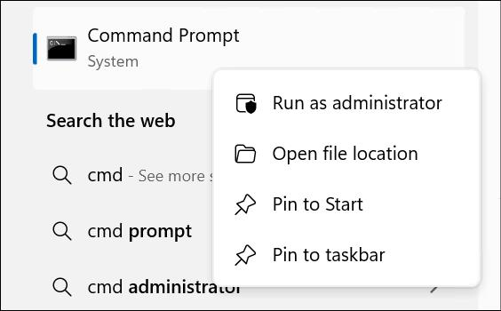
7. **Open Sysprep Tool**: Run the following command to open Sysprep:

%WINDIR%\system32\sysprep\sysprep.exe

1. **Prepare the Image**: Sysprep removes PC-specific information, preparing the installation for imaging and deployment across multiple machines.
2. **Select 'Out of Box Experience'**: In the system cleanup dropdown, select “Enter System Out of Box Experience.”
3. **Generalize the Image**: Check the "Generalize" option.
4. **Shutdown Option**: Under "Shutdown Options," select "Shutdown."

1. **Execute Sysprep**: Click OK. The VM will automatically shut down after completing the process.
2. \A screenshot of a computer

   AI-generated content may be incorrect.

Once sysprep done , VM will shut down and we will do Image capturing process.

1. **Capture the Image**: After shutdown, click the "Capture" option and select "Image."

1. **Subscription & Resource Group**: The subscription will automatically be assigned to the VM. Select the appropriate resource group.

1. **Gallery & Version Details**: Add gallery details and version information. Keep other options as they are.

1. **Review and Create**: Click on "Review and Create" and, once validation passes, click "Create."

1. **Image Creation**: The VM will stop, and the image creation process will begin. You will see a "Work in Progress" message.

1. **Image Deployment**: Once deployment is complete, navigate to the resource section.

1. **Access the Created Image**: The newly created image will be displayed.

1. **Delete Base VM**: Once the image is successfully created, you may delete the base VM.

This streamlines the process while maintaining clarity and focus.

# Deploying a License Server for NX

Before we create AVD Virtual Machines with NX installed on them, we need to configure or setup the license server to run the NX on AVD session Hosts. For the license server setup, we need to install a Windows VM in azure and then install the Siemens License Server manager in the VM.

Follow the steps given in the link below to create a Windows Virtual Machine in the Azure

<https://learn.microsoft.com/en-us/azure/virtual-machines/windows/quick-create-portal>

Once the VM is created, login to the VM and install the License server Manager.

1. Start by clicking on the link, which will bring you to Siemens License Server Downloads. And download “SiemensLicenseServer_v4.2.0.0_Win64_x86-64.exe”

<https://support.sw.siemens.com/en-US/product/1586485382/download/202410063>

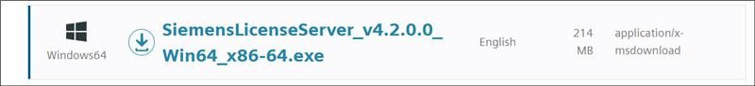

1. Right click on the package below and Run as administrator

1. Choose your language. Click OK.

1. Click Next .

1. To import a license file:

Click the "Browse" button to select your license file.

If you don't have a license file ready:

You can click "Skip" to proceed without importing a license.

You'll have the option to specify a license file later, either: a) After completing the license server installation, or b) By running the installer again.

1. Important note: If you don't provide a valid license file, the license manager service will not start automatically after installation.

1. The Port Changes window will display:

License serving port: 29000

Vendor daemon port: 29001

To modify these ports before installation:

Check the "Advanced Settings" box

Enter your desired port numbers

Important considerations:

Ensure the chosen ports are available

Verify that the two port numbers are different

Remember to update the SPLM_LICENSE_SERVER environment variable with any new port numbers

After reviewing or making changes, click "Next" to proceed.

1. In the Installation Location window, type the path or browse to the location where you want to install the license server. The field shows the default location. Click Next.

We have the Enter webkey feature but we haven’t selected below feature , so we clicked on “I don’t want this feature” checkbox.

1. In the Enter Webkey window, type your Siemens account (Webkey) or Support Center login, which is in email address format. Or, if you do not yet have a Siemens account, type the email that you will provide when you sign up for an account. The email you enter in this window is encrypted and stored locally on the server and is not sent to Siemens or used for any other purpose. Providing a Webkey installs the Siemens License Install Manager (SLIM), enabling you to manage your license servers remotely from a Windows machine on your network. If you do not want to install SLIM, select the "I don't want this feature" check box. Click Next.

1. In the Confirmation Installation page, verify you want to keep the selected check box at the bottom to allow other users to access the computer you are installing the server on. The note reads “Required to serve licenses to clients on your network from this host.”

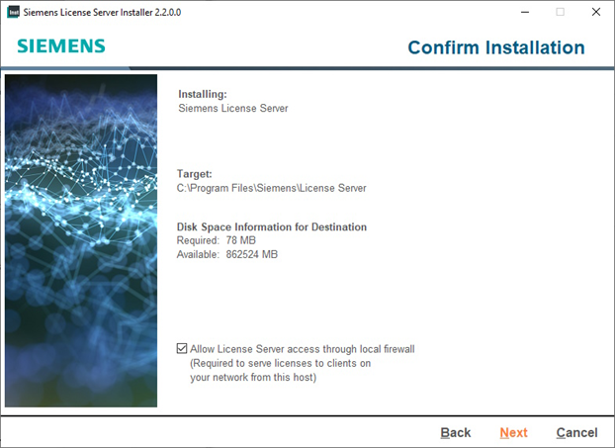

1. Clicking Next will begin the installation process.
2. Click done once installation completed
3. Log in to server machine and verify the Siemens License Server process is running by checking the Task Manager on the server machine.

# Azure Virtual Desktop High-Level Architecture

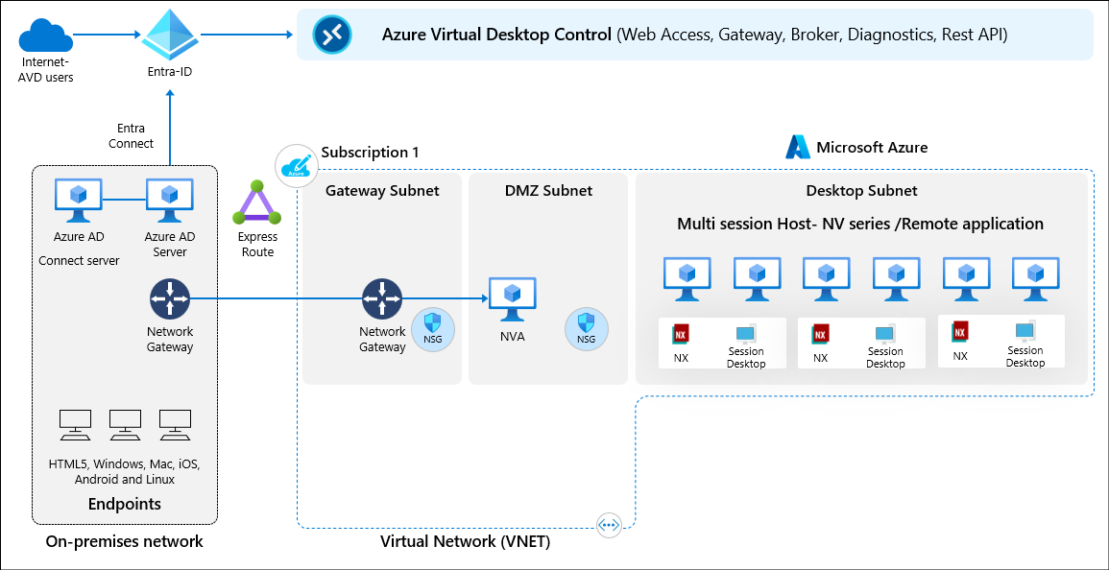

Azure Virtual Desktop (AVD) consists of several key components that work together to deliver a scalable, secure, and high-performance virtual desktop experience.

1. **Host Pool:**

A host pool is a collection of one or more virtual machines (VMs) that serve as session hosts for user connections

**Pooled Host Pool:** Multiple users share session hosts, optimizing resource usage.

**Personal Host Pool:** Each user gets a dedicated VM for a persistent desktop experience

1. **Session hosts:**

Session hosts are Azure Virtual Machines (VMs) that run Windows 10/11 Multi-Session or Windows Server. They host the actual user sessions.

Can be deployed in Availability Sets or Availability Zones for high availability.

Can be optimized using FSLogix for profile management

1. **Workspace & Application Groups**

**Workspace**: A logical container for published desktops and applications.

**Application Group (App Group)**: Defines which apps or desktops are accessible to users.

**Desktop Application Group (DAG)**: Provides full desktop access.

**RemoteApp Application Group (RAG)**: Publishes specific applications instead of the full desktop.

1. **Identity Authentication**

Uses Microsoft Entra ID (formerly Azure AD) for authentication.

Supports Multi-Factor Authentication (MFA), Conditional Access, and Single Sign-On (SSO).

Can integrate with Azure AD Join or Hybrid AD Join for identity management.

1. Networking & Connectivity

# AVD Deployment

To deploy an Azure Virtual Desktop in Azure cloud, please follow the below documentation on Azure Virtual Desktop

[Azure Virtual Desktop documentation | Microsoft Learn](https://learn.microsoft.com/en-us/azure/virtual-desktop/)

### Creation of Host pools

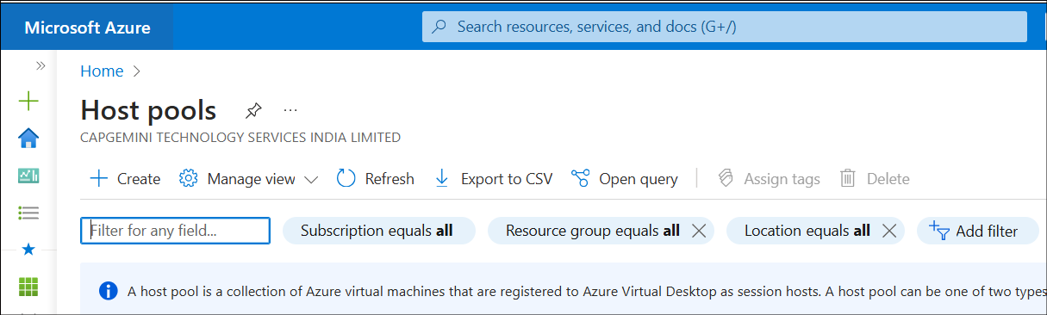

Enter Resource group , Host pool name, location,

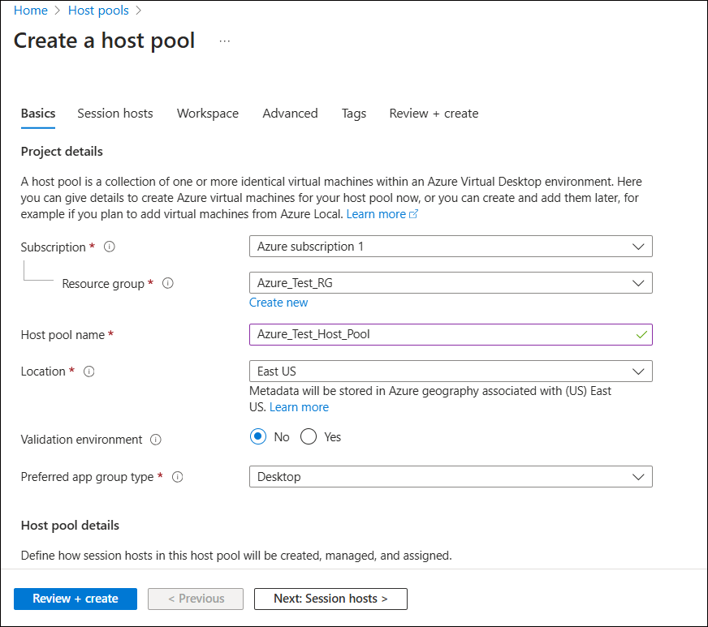

Enter Preferred app group type – Desktop (and for the second application group – Remote App) Host pool type - Pooled

Under Virtual Machine , Enter resource group and Name Prefix

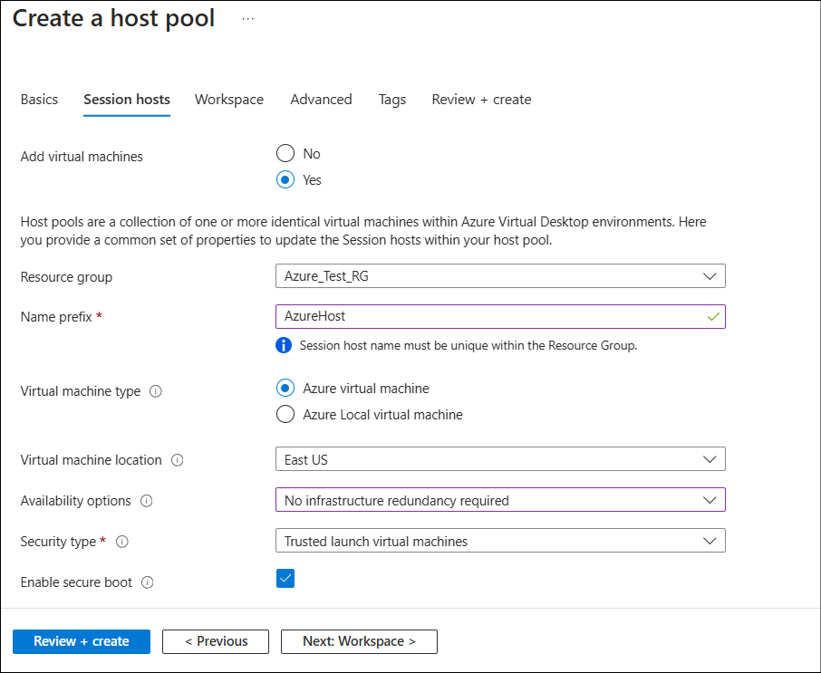

Select the master image which is created before and Virtual Machine size as V series

Click on see all images

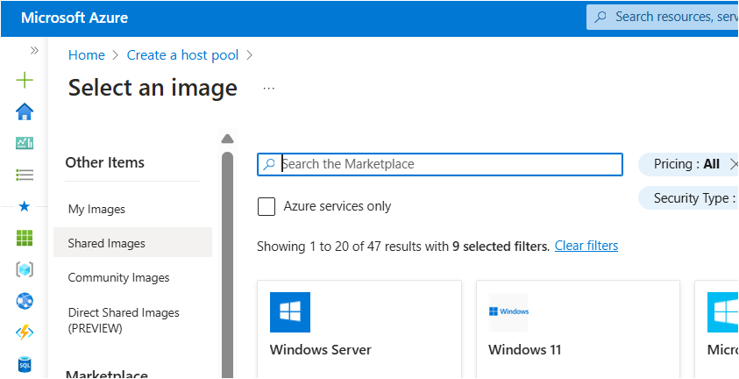

Navigate to 'Shared Images' to locate the Master Image you previously created.

Select the Master Image you created to it will add it to the Host Pool creation process.  
e.g Azure Test Image

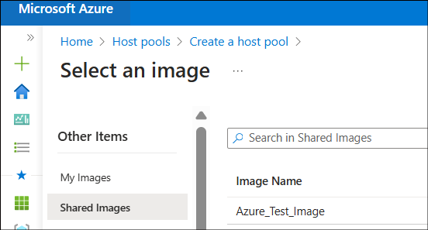

Enter the username and its password for the VMs to login

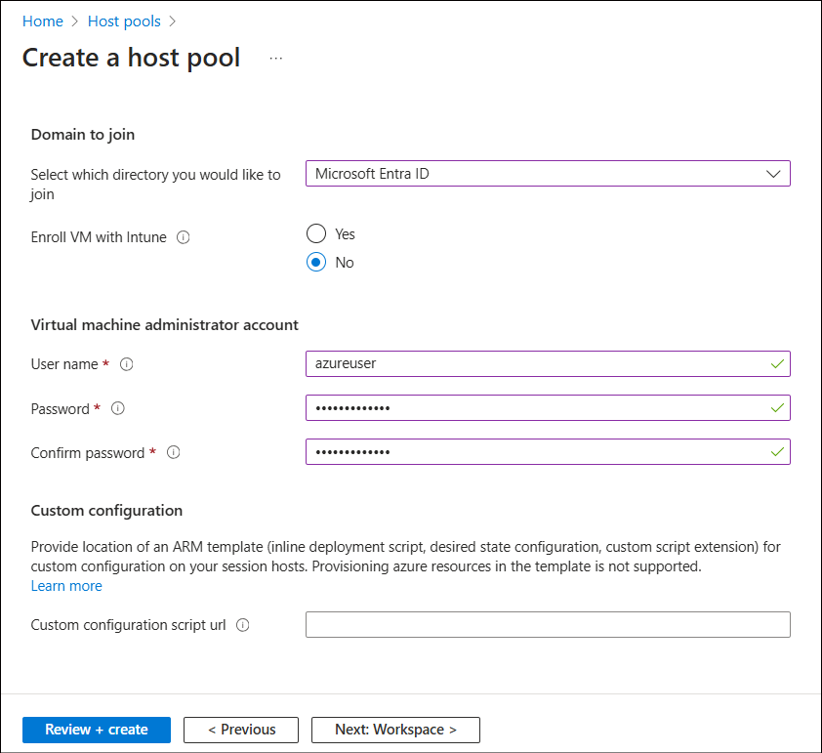

Click on Review + Create. It will validate. Once Validation is passed.

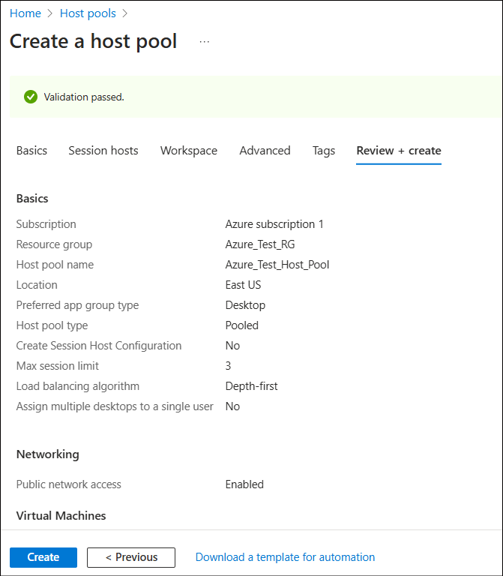

It will go for deployment process and once deployment completed , It will create Host pool and VMs.

### Creation of Application group

#### Addition of Desktop App as Application group

When creating a host pool in Azure Virtual Desktop, if you select "Desktop" as the preferred application type, there's no need to separately create a Desktop application group. The system automatically generates a Desktop application group as part of the host pool creation process. This Desktop application group can then be used to provide users with access to full desktop sessions.

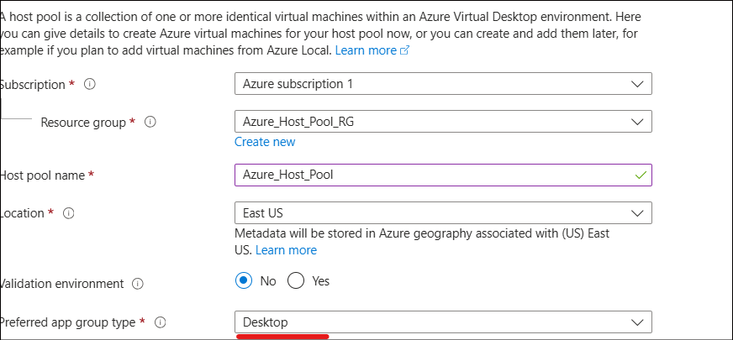

This streamlined approach simplifies the setup process, as you don't have to manually create and configure a separate Desktop application group after establishing the host pool. The automatically created Desktop application group is ready to use for assigning full desktop access to your users.

#### Addition of Remote App as Application group

It will open the Application Source

From the application drop down, select NX

Click on Review + add

Click on Add

Review + create. It will validate. Once validation is passed. Click on create to create

Click on Create to create the application group.

After creation, click on Assignment tab

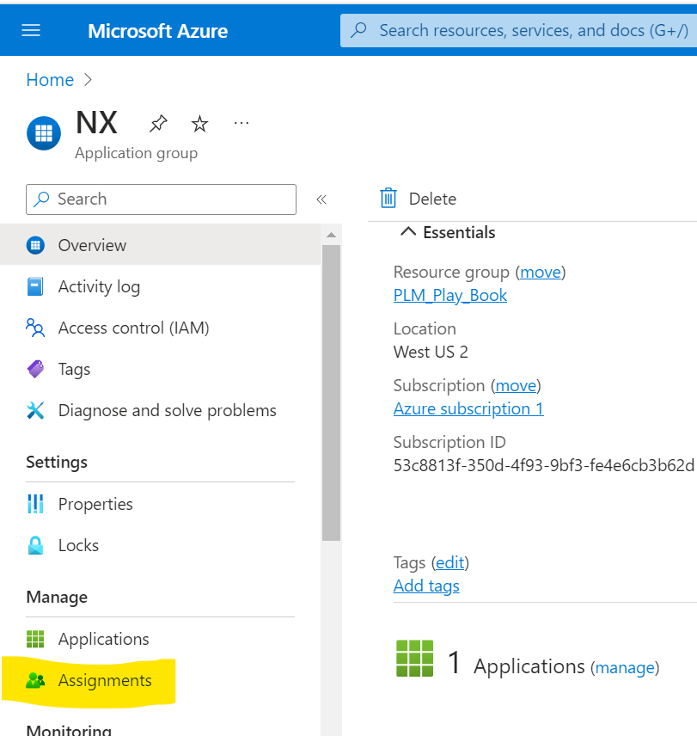

Under assignments, click on Add to add the users who can access the application

Once assignment was done, you can see no of users added under assignments

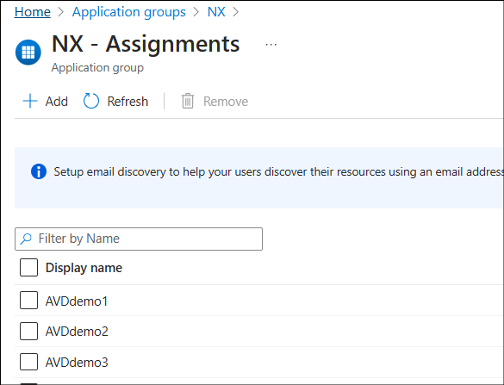

Once Application group is completed, we need to create Workspace

Creation of Application Workspace

Search for Workspace and open the workspace tab

Click on create to create a new workspace

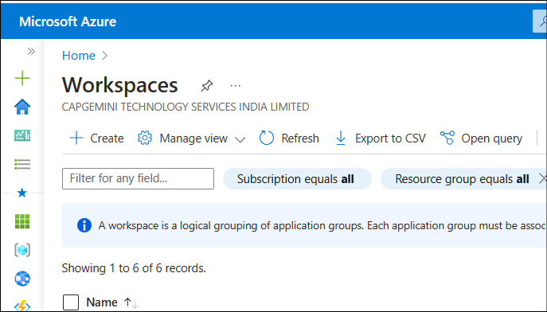

Enter the resource group, Workspace

Click on Review + create. Once Validation is passed , you can click on create to create the workspace

Open the Workspace and add the application group

Click on Add

It will show the available Application group.

Click on + to add

### Addition of roles to the Resource group

Add the users to the following groups

1. Desktop virtualization user
2. Virtual machine Administrator login
3. Virtual machine user login

### Addition of users to these above roles

Click on IAM (Access Control) and go to Role assignments and add the role to specific users.  
In this case we have created a group of users (AVD_NX_TESTING) and added group for above roles.

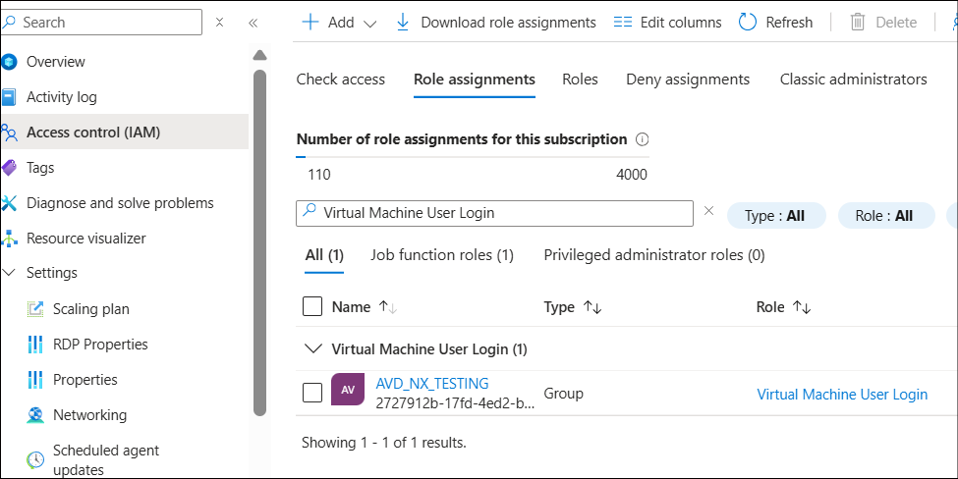

### Configuring Remote Desktop Application

Need to add details about ;what is Remote Desktop application ?

Open the Remote Desktop application which is installed locally.

Subscribe with URL

<https://rdweb.wvd.microsoft.com/api/arm/feeddiscovery>

It will take to Microsoft authentication, enter your mail id and credentials.

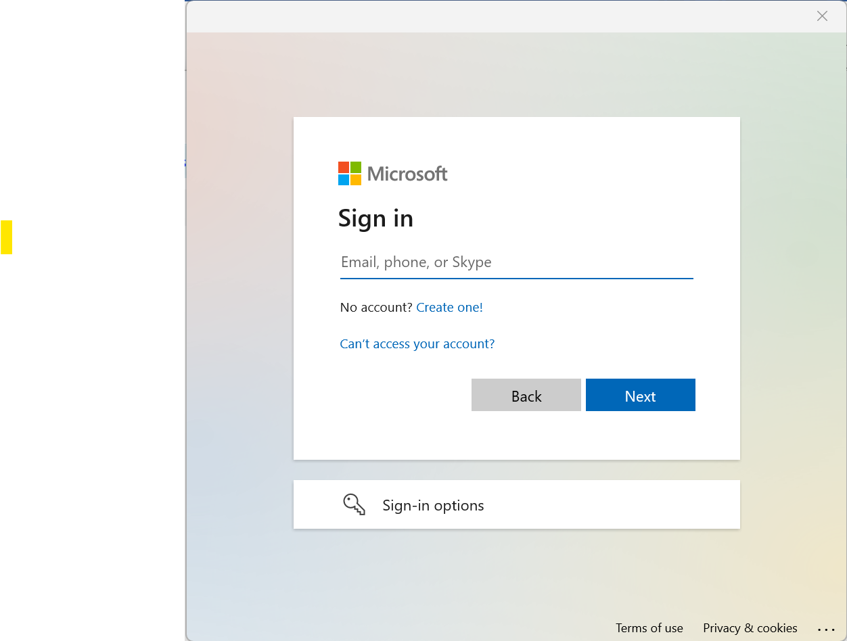

Once signed in,

It will show the Applications in Remote Desktop

Accessing NX from Remote Desktop Application

Once you Double Click on NX icon, it will open as Remote app and you can work and save the models

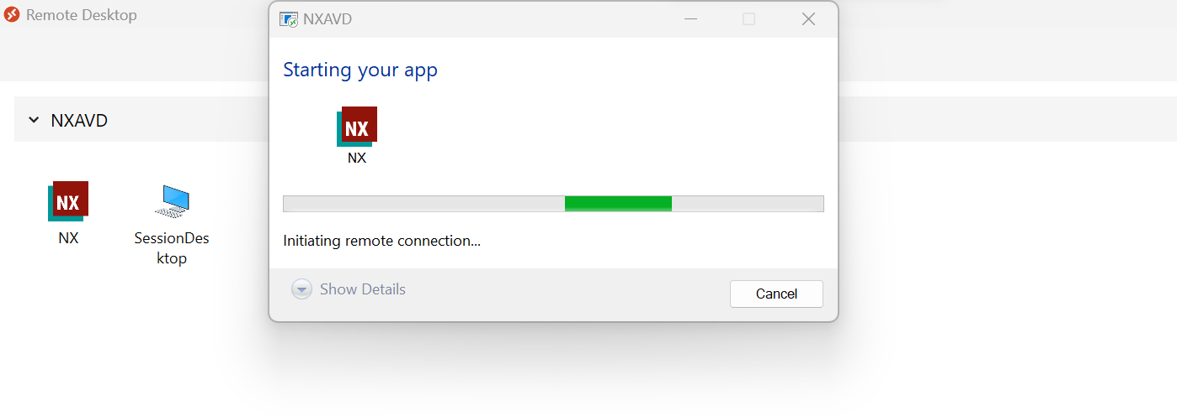

NX application opens

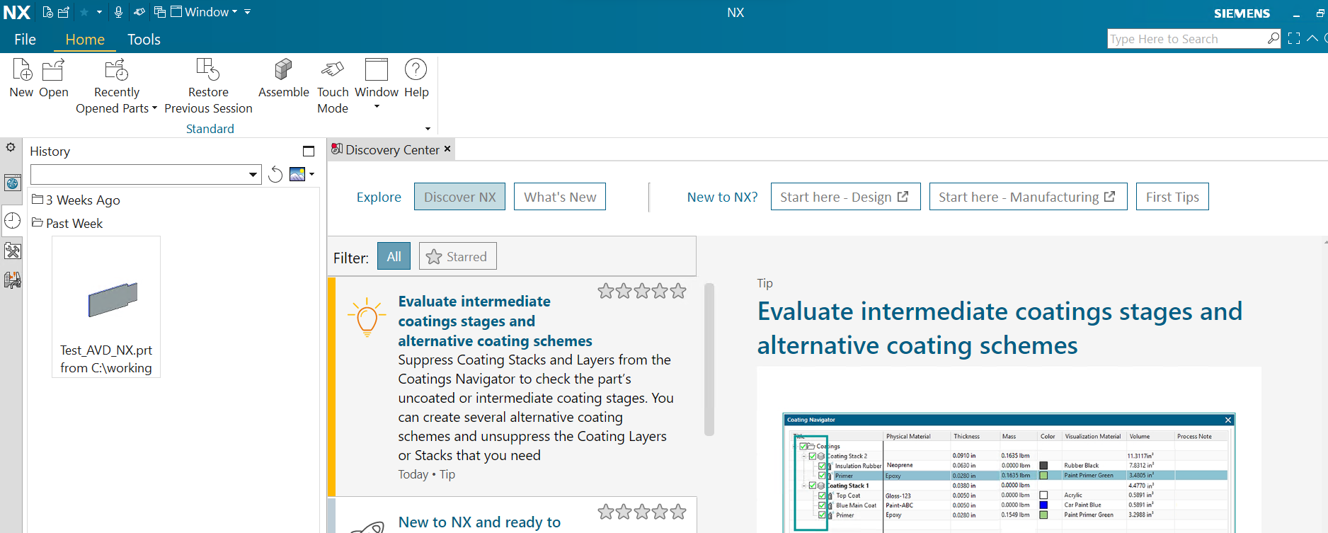

Create a model and save

